**IOT BASED AIR POLLUTION MONITORING SYSTEM USING ARDUINO**

by

DEEKSHETHA H R 19BEC1034

S SUKKRISHVAR VIJAY 19BEC1063

S RESHMA 19BEC1393

SHRIMAYEE DESHPANDE 19BLC1034

A project report submitted to

**Dr. Prakash V**

**SCHOOL OF ELECTRONICS ENGINEERING**

in partial fulfilment of the requirements for the course of

**ECE4003 – Embedded System Design**

in

**B.Tech. Electronics and Communication Engineering**



**VIT CHENNAI**

**Vandalur-Kelambakkam Road**

**Chennai – 600127**

**JULY 2021**

**BONAFIDE CERTIFICATE**

Certified that this project report entitled “**IOT BASED AIR POLLUTION MONITORING SYSTEM USING ARDUINO”** is a bona fide work of **DEKSHETHA H R (19BEC1034), S SUKKRISHVAR VIJAY (19BEC1063), NAGENDRAN K (19BEC1042), S RESHMA (19BEC1393) and SHRIMAYEE DESHPANDE (19BLC1034)** who carried out the Project work under my supervision and guidance.

**Dr. Prakash V**

Assistant Professor

School of Electronics Engineering (SENSE),

VIT Chennai

Chennai - 600127.

**ABSTRACT**

The amount of air pollution in the atmosphere is increasing due to the major use of vehicles, industries and urbanization. With the boom in IOT nowadays, we have the availability of data everywhere. On one click, we can be assured of the quality of air around us. This application can be of major use in industrial areas/ highly polluted areas, where you can assure yourself about the quality of air around you. In case of industries, this product can be implanted in specific areas, where analysis of air quality is a must, and it will keep reading data and updating on cloud, so that you can access the data from anywhere and don’t always have to be on site to make sure everything is fine. It gives us notification about the air quality monitoring system that is built. From this project, we can check the air quality in serial monitor, thingspeak, LCD as well as in webpage.

**ACKNOWLEDGEMENT**

We wish to express our sincere thanks and deep sense of gratitude to our project guide, **Dr. Prakash V,** Associate Professor Senior, School of Electronics Engineering, for his consistent encouragement and valuable guidance offered to us in a pleasant manner throughout the course of the project work.

We are extremely grateful to **Dr. A. Sivasubramanian,** Dean of the School of Electronics Engineering, VIT Chennai, for extending the facilities of the school towards our project and for her unstinting support.

We also take this opportunity to thank all the faculty of the school for their support and their wisdom imparted to us throughout the course.

We thank our parents, family, and friends for bearing with us throughout the course of our project and for the opportunity they provided us in undergoing this course in such a prestigious institution.



**DEEKSHETHA H R S RESHMA S SUKKRISHVAR VIJAY SHRIMAYEE DESHPANDE**

**19BEC1034 19BEC1393 19BEC1063 19BLC1034**

TABLE OF CONTENTS

SECTION 1 – INTRODUCTION .......................................................................................................

1.1 OBJECTIVE 6

1.2 INTRODUCTION 6

1.3 FEATURES 6

SECTION 2 – EMBEDDED DESIGN PROCESS .........................................................................

2.1 REQUIREMENT 7

2.1.1 PURPOSE 7

2.1.2 INPUTS 7

2.1.3 OUTPUTS 7

2.1.4 FUNCTIONS OF THE SYSTEM 7

2.1.5 DESIGN METRICS 8

2.2 SPECIFICATIONS 9

2.3 ARCHITECTURE 8

2.3.1 BLOCK DIAGRAM FOR HARDWARE 8

2.3.2 BLOCK DIAGRAM FOR SOFTWARE 9

2.3.3 BLOCK DIAGRAM OF THE OVERALL SYSTEM……………………………………….….10

2.4 COMPONENTS REQUIRED 11

2.5 SYSTEM INTEGRATION 11

SECTION 3 – SOFTWARE IMPLEMENTATION IN ARDUINO IDE AND FRITZING ............

3.1 SOFTWARE ANALYSIS 11

3.1.1 CIRCUIT SOFTWARE REQUIREMENT 12

3.1.2 API USED 12

3.1.3 ALGORITHM 12-14

3.2 CODE IMPLEMENTED IN ARDUINO IDE 14-21

3.2.1 WINDOWS DISPLAYING THE CODE 21-28

3.3 SOFTWARE IMPLEMENTATION IN FRITZING 28-29

3.4 SOFTWARE IMPLEMENTATION IN THINGSPEAK 29-32

3.5 SOFTWARE IMPLEMENTATION IN WEBPAGE 33

3.6 SOFTWARE IMPLEMENTATION IN IFTTT 34-41

SECTION 4 – HARDWARE IMPLEMENTATION ...........................................................................

4.1 HARDWARE ANALYSIS 42

4.1.1 NODEMCU 42-44

4.1.2 LCD DISPLAY 44-45

4.1.3 BUZZER 45-46

4.1.4 DHT11 46-47

4.1.5 MQ135 GAS SENSOR 47-48

4.1.6 OUTPUTS OBTAINED IN HARDWARE 49

SECTION 5 .........................................................................................................

5.1 APPLICATIONS 50

5.2 ADVANTAGES AND DISADVANTAGES 50-51

5.3 CONCLUSION 51

5.4 REFERENCES 51

**INTRODUCTION**

**1.1 OBJECTIVES**

* Designing a virtual circuit in Fritzing.
* Detects the level of air pollution in ppm using Node MCU
* Designing the code for loading into the Node MCU from Arduino IDE

**1.2 INTRODUCTION**

The air quality is very influential on the state of the population in an area because the air quality can cause damages to all the living things1. Poor air quality can impact health which would be the threat to the living beings. To prevent the instability in the air quality, an air quality monitoring system is required so that there won’t be any instability in the health aspect in and around our surroundings. Air quality monitoring can be done by measuring temperature, humidity and air-contained compounds including CO, CO2, NH3, NOx, Alcohol, Benzene, Smoke levels in the air. Nowadays the technology has been developing tremendously, so by using this technology that is using sensors and the cloud platform we can measure the condition of the air quality2. In this project, we have designed an IoT based monitoring system to monitor air quality system. Monitoring is done by collecting data from several sensors that can be accessed remotely through thing speak, web page.

**1.3 FEATURES**

* The implementation of the Iot Based Air Pollution Monitoring System Using Node MCU
* Use of devices such as MQ135 gas sensor, DHT11 sensor, Node MCU and LCD.
* The efficient coding in the software tool Arduino IDE.

**2. EMBEDDED DESIGN PROCESS**

**2.1 REQUIREMENT**

Basic description of the system is described in this process

**2.1.1. PURPOSE**

* To monitor the CO, CO2, NH3, NOx, Alcohol, Benzene, Smoke levels in the air.
* To monitor the temperature and humidity level of the environment.
* To conclude the quality of air, if high PPM, switch on the buzzer.

**2.1.2. INPUTS**

* MQ135 Gas Sensor
* DHT11 temperature and humidity sensor

**2.1.3. OUTPUTS**

* Value of air quality in PPM would be displayed on the LCD display.
* Value of air quality in PPM, temperature and humidity level would be displayed on the web page.
* Buzzer output if air quality is above a certain threshold.

**2.1.4. FUNCTIONS OF THE SYSTEM**

* The MQ135 gas sensor detects the gases present in the air.
* The system then calculates the level of gases in the given sample and converts the value into parts per million with constraints.
* The PPM value is then sent to the system database and is displayed on the LCD display and is also updated on the website using ESP8266 Wi-Fi module.
* The DHT11 sensor monitors the temperature and humidity of the given area and sends the values to the database.
* These values are then updated on the website using ESP8266 Wi-Fi module.
* In case of high PPM, buzzer is switched on.
* Including sending the data on thing speak cloud.

**2.1.5. DESIGN METRICS**

* 5V for the gas sensor, 3V for the DHT11 sensor as required by the display units and computer system.
* Performance: Sensor data refreshed every 1000ms i.e., 1 second.
* UI: The website would be developed in HTML.
* Cost: Rs 2000

**2.2. SPECIFICATIONS**

* **WEBPAGE:** The webpage is built in HTML and imports data read by the DHT11 sensor. It displays the value of temperature and humidity. It also displays the PPM value calculated by the system based on the MQ135 sensor. It displays the quality of air based on the PPM value.
* **LCD DISPLAY:** It displays the PPM value calculated by the system.
* **BUZZER:** If the PPM value is above a certain threshold, the buzzer is turned on to indicate that the air quality is not good.

**2.3. ARCHITECTURE**

**2.3.1. BLOCK DIAGRAM FOR HARDWARE**

The four main features of the basic block diagram (Refer Figure 1) are

* Node MCU
* LCD Display
* Potentiometer
* Buzzer
* MQ135 Gas Sensor
* DHT11 Temperature and Humidity Sensor

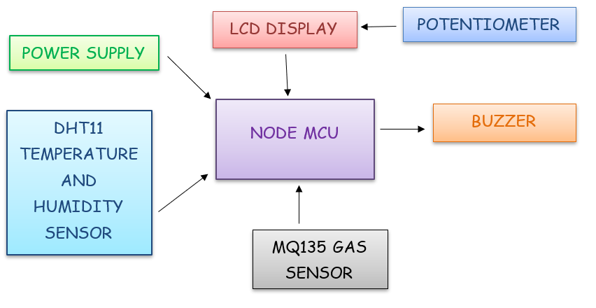

**Figure 1 Hardware Block Diagram**

**2.3.2. BLOCK DIAGRAM FOR SOFTWARE**

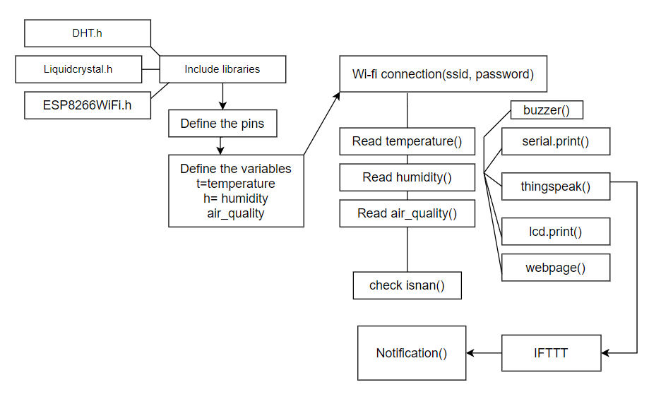

**Figure 2 Software Block Diagram**

**SOFTWARE DIAGRAM EXPLANANTION:**

* Wi-fi connected (ssid, password) - this function is responsible to establish the internet connection of the inbuilt esp8266 Wi-Fi module.
* Read temperature ()- reads the temperature value in degree Celsius
* Read humidity ()- reads the humidity value in percentage
* Read air_quality ()- reads the air quality value in ppm.
* Check isnan ()- checks if any of the sensor value is nan. In case it’s nan, print an error message on the serial monitor.
* buzzer ()- if any of the parameter value exceeds a particular limit, the buzzer is switched on. Else its off.
* serial.print ()- the temperature, humidity and air quality values are printed on the serial monitor.
* thingspeak ()- the temperature, humidity and air quality values are sent on the thingspeak clout at the given api key.
* lcd.print ()- the temperature, humidity and air quality values are printed on the LCD display
* webpage ()- a local host webpage is created and the air quality is printed on the page along with the information if its safe or not.
* IFTTT- if this then that, this produces an api, which is activated when the temperature/humidity/air quality limit is exceeded and further it sends notification to the user.
* notification ()- it can be in the form of an email or a text message (SMS) or a phone call etc.

**2.3.3. BLOCK DIAGRAM FOR OVERALL ARCHITECTURE DIAGRAM**

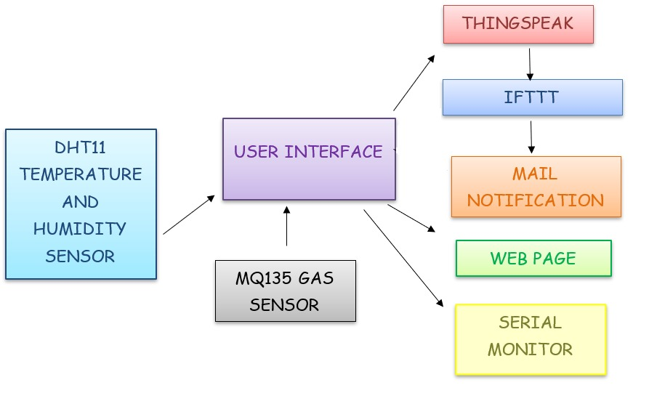

**Figure 3 Overall Architecture Diagram**

**2.4. COMPONENTS REQUIRED**

|  |  |
| --- | --- |
| *HARDWARE COMPONENTS* | *SOFTWARE COMPONENTS* |
| * MQ135 GAS SENSOR | * ARDUINO IDE |
| * DHT11 | * WEB PAGE USING HTML PROGRAMMING |
| * NODE MCU ESP8266 | * THINGSPEAK |
| * BREAD BOARD | * FRITZING APP |
| * 16 X 2 LCD | * IFTTT |
| * 10K POTENTIOMETER |  |
| * 1K OHM RESISTOR |  |
| * 220 OHM RESISTOR |  |
| * BUZZER * JUMPPER WIRES |  |

**Table 1 shows the Components for the project**

**2.5. SYSTEM INTEGRATION**

*TEST AND VALIDATION CONDITIONS:*

* All sensors should detect the data precisely.
* LCD Display and Buzzer should work as per the program.
* The updating of the Data in website should work as per the program.
* Each sensor should be tested with different surrounding conditions.
* Tested for 3 times a day for 2 weeks.

**3. SOFTWARE IMPLEMENTATION IN ARDUINO IDE AND FRITZING**

**3.1 SOFTWARE ANALYSIS**

Simulation software is based on the process of modelling a real phenomenon with a set of mathematical formulas. It is, essentially, a program that allows the user to observe an operation through simulation without actually performing that operation.

**3.1.1 CIRCUIT SOFTWARE REQUIREMENTS**

*Arduino IDE*

The Arduino IDE is an open-source software, which is used to write and upload code to the Arduino boards. The IDE application is suitable for different operating systems such as **Windows, Mac OS X, and Linux**.

It supports the programming languages C and C++. Here, IDE stands for **Integrated Development Environment**.

The program or code written in the Arduino IDE is often called as sketching. We need to connect the Genuino and Arduino board with the IDE to upload the sketch written in the Arduino IDE software. The sketch is saved with the extension '.ino.'

**3.1.2. API USED:**

* **int setupESP8266():** This function will start Serial connection over USB to Computer, Tx / Rx port to ESP8266 and open TCP connection to the host
* **void sendThingspeak ():** This function constructs HTTP call and sends our HTTP request to respective channels based on API keys on Thing Speak API
* **void sendWebserver ()**: This function is used to send to send the server request to obtain the web server.

**3.1.3. ALGORITHM**

**ALGORITHM USED FOR THINGSPEAK IMPLEMENTATION**

* Initialize the ESP8266WiFi library. Import it.
* Set the api Key to the thing speak key.
* Define SSID password of Wi-Fi connection.
* Define MQ135 sensor pin as A0.
* In setup, initialize the serial monitor at 115200 baud rates. Connect to Wi-Fi.
* In the loop, read the sensor value from the analog pin. In case the value is nan (i.e., the sensor is not connected properly), give out an error message.
* Once the connection is established properly, upload the value read by the sensor on thing speak api based on the apikey.
* Refresh the sensor value every second.
* In thing speak, plot the graph.

**ALGORITHM USED FOR WEBPAGE IMPLEMENTATION**

* Include the ESP8266WiFi library.
* Define the A0 pin for MQ135 sensor. Also define the digital pin D2 for buzzer.
* Define the ssid and password of Wi-Fi.
* Initialize a wifiserver
* In the setup, using pinMode, define the pins as input/output pins.
* Initialize the serial monitor at 115200 baud rate.
* Establish the Wi-Fi connection.
* In the loop, read the analog value from the sensor and display it on the serial monitor. Once the connection is established, initialize a webpage (local host). Push the sensor data on the webpage.
* Using conditionals, according to the ppm value, display the danger level.

**FLOWCHART USED IN THE INTERFACING OF LCD**

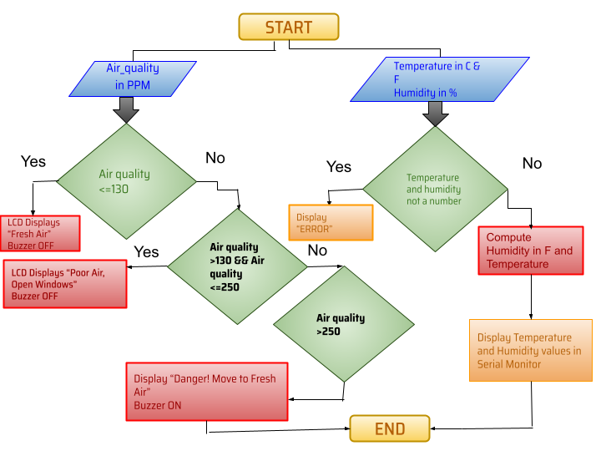

**Figure 4 Flow Chart of LCD interfacing with Node MCU**

**3.2 CODE IMPLEMENTED IN ARDUINO IDE**

#include <DHT.h>

#include <ESP8266WiFi.h>

#include <LiquidCrystal.h>

const int rs = D0, en = D1, d4 = D4, d5 = D5, d6 = D6, d7 = D7;

float air_quality;

float air_quality1;

const int buzzer = D2;

unsigned long interval = 10000;

unsigned long previousMillis = 0;

unsigned long interval1 = 1000;

unsigned long previousMillis1 = 0;

LiquidCrystal lcd(rs, en, d4, d5, d6, d7);

const char *ssid = "Galaxy J6458D"; // Enter your WiFi Name

const char *pass = "eddp9327"; // Enter your WiFi Password

String apiKey = "4CKLBI1LTCDWYUMQ"; // Enter your Write API key here

const char* server = "api.thingspeak.com";

WiFiClient client;

WiFiServer server1(80);

#define DHTPIN D3 // GPIO Pin where the dht11 is connected

DHT dht(DHTPIN, DHT11);

float h; // humidity reading

float h1;

float t; //temperature reading

float t1;

void setup()

{

Serial.begin(115200);

dht.begin();

pinMode(buzzer,OUTPUT);

lcd.begin(16, 2);

delay(10);

Serial.println("Connecting to ");

lcd.print("Connecting.... ");

Serial.println(ssid);

WiFi.begin(ssid, pass);

while (WiFi.status() != WL_CONNECTED)

{

delay(550);

Serial.print(".");

lcd.print(".");

}

Serial.println("");

Serial.println("WiFi connected");

Serial.print("IP Address: ");

Serial.println(WiFi.localIP());

server1.begin();

}

void loop()

{

unsigned long currentMillis = millis(); // grab current time

h = dht.readHumidity(); // read humiduty

t = dht.readTemperature(); // read temperature

if (isnan(h) || isnan(t))

{

Serial.println("Failed to read from DHT sensor!");

return;

}

delay(500);

lcd.clear();

lcd.setCursor(0, 0);

lcd.print("Pollution = ");

float air_quality = analogRead(A0);

//air_quality = ((analogRead(A0)/1024.0)*100.0);

lcd.print(air_quality);

lcd.print("PPM");

//Serial.println(air_quality);

if ((unsigned long)(currentMillis - previousMillis1) >= interval1)

{ Serial.print("Air Quality:");

Serial.print(air_quality);

Serial.print(" ppm");

Serial.println();

Serial.print("Temperature: ");

Serial.print(t);

Serial.print(" C");

Serial.println();

Serial.print("Humidity: ");

Serial.print(h);

Serial.print(" %");

Serial.println();

previousMillis1 = millis();

}

lcd.clear();

lcd.setCursor(0, 0);

lcd.print("Pollution=");

lcd.print(air_quality);

lcd.print("ppm");

lcd.setCursor (0,1);

if(air_quality <= 130)

{

lcd.print("Fresh Air");

digitalWrite(buzzer,LOW);

}

else if (air_quality > 130 && air_quality <= 250)

{

lcd.print("Poor Air, Open Windows");

digitalWrite(buzzer,LOW);

}

else

{

lcd.print("Danger! Move to Fresh Air");

digitalWrite(buzzer,HIGH);

}

lcd.scrollDisplayLeft();

delay(1000);

if ((unsigned long)(currentMillis - previousMillis) >= interval)

{

sendThingspeak(air_quality,t,h); //send data to thing speak

previousMillis = millis();

client.stop();

}

if ((unsigned long)(currentMillis - previousMillis) >= interval)

{

sendWebserver(air_quality,t,h); //send data to Webserver

previousMillis = millis();

client.stop();

}

}

void sendThingspeak(float air_quality1,float t1,float h1)

{

if (client.connect(server, 80))

{

String postStr = apiKey; // add api key in the postStr string

postStr += "&field1=";

postStr += String(air_quality1); // add air_quality reading

postStr += "&field2=";

postStr += String(t1); // add tempr readin

postStr += "&field3=";

postStr += String(h1); // add humidity readin

postStr += "\r\n\r\n";

client.print("POST /update HTTP/1.1\n");

client.print("Host: api.thingspeak.com\n");

client.print("Connection: close\n");

client.print("X-THINGSPEAKAPIKEY: " + apiKey + "\n");

client.print("Content-Type: application/x-www-form-urlencoded\n");

client.print("Content-Length: ");

client.print(postStr.length()); //send lenght of the string

client.print("\n\n");

client.print(postStr); // send complete string

Serial.println("%. Sent to Thingspeak.");

}

}

void sendWebserver(float air_quality1,float t1,float h1)

{

WiFiClient client = server1.available();

if ( client.connected())

{ // loop while the client's connected

// HTTP headers always start with a response code (e.g. HTTP/1.1 200 OK)

client.println("HTTP/1.1 200 OK");

client.println("Content-type:text/html");

client.println("Connection: close");

client.println("Refresh: 3"); // update the page after 3 Sec.

client.println();

// turns the GPIOs on and off

lcd.setCursor(0,1);

lcd.print("Sending Data" );

// Display the HTML web page

client.println("<!DOCTYPE html><html>");

client.println("<head><meta name=\"viewport\" content=\"width=device-width, initial-scale=1\">");

client.println("<link rel=\"icon\" href=\"data:,\">");

// Web Page Heading

client.println("<body><h1 style=\"color:orange;\"> Air Quality Monitoring </h1>");

client.println("<body><p style=\"color:blue;\"> Pollution Content(in ppm) = " + String(air_quality1) +" ppm"+ " </p>");

client.println("<body><p style=\"color:blue;\"> Temperature(in C) = " + String(t1) +" C"+ " </p>");

client.println("<body><p style=\"color:blue;\"> Humidity(in %) = " + String(h1) +" %"+ " </p>");

if(air_quality1 <= 130)

{

client.println("<body><p style=\"color:green;\"> Fresh Air </p>");

}

else if (air_quality1 > 130 && air_quality1 <= 250)

{

client.println("<body><p style=\"color:purple;\"> Poor Air </p>");

}

else

{

client.println("<body><p style=\"font-size:200%; color:red\"> Danger! Move to Fresh Air </p>");

}

client.println("</body></html>");

delay(1000);

}

}

**3.2.1 WINDOW DISPLAYING THE CODE**

Snapshots of the Arduino IDE code for the project (Refer Figure 5,6,7,8,9,10,11,12,13)

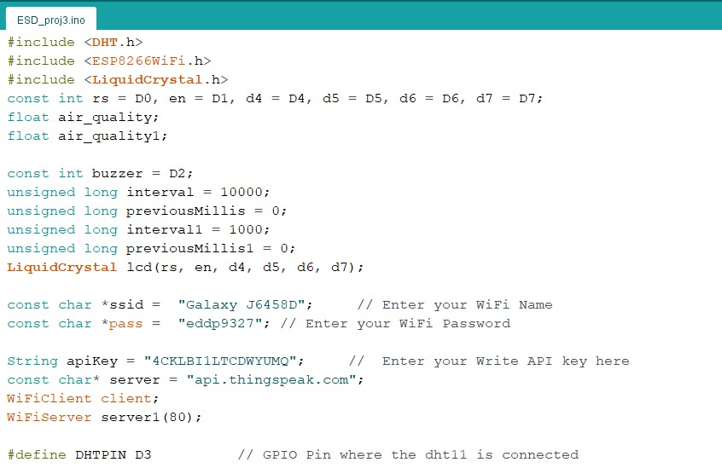

**Figure 5 Arduino IDE code window**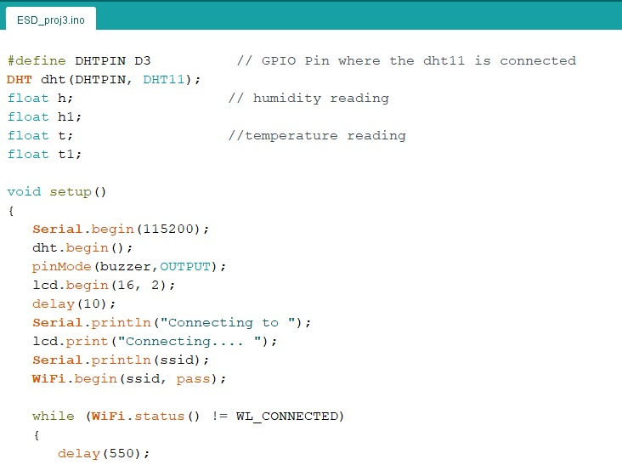

**Figure 6 Arduino IDE code window**

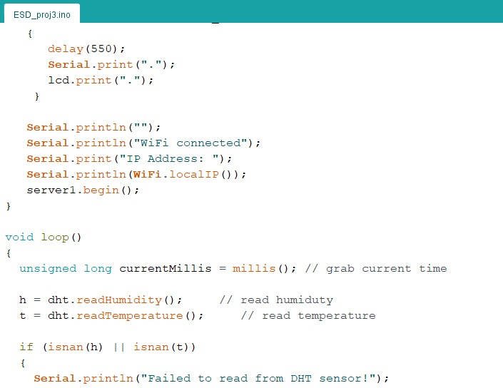

**Figure 7 Arduino IDE code window**

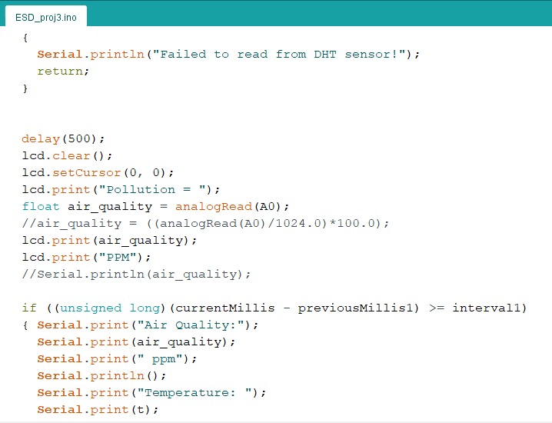

**Figure 8 Arduino IDE code window**

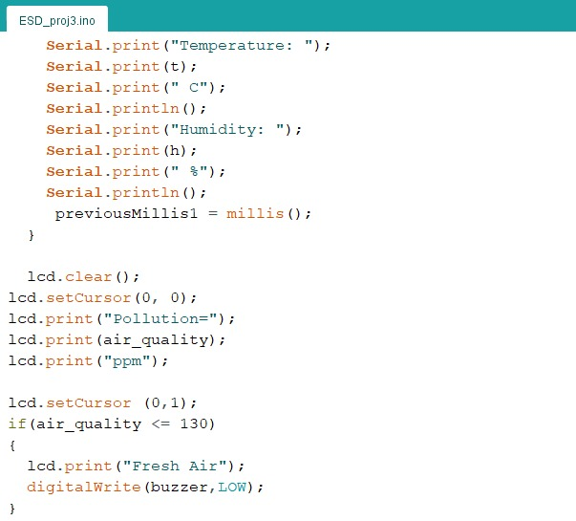

**Figure 9 Arduino IDE code window**

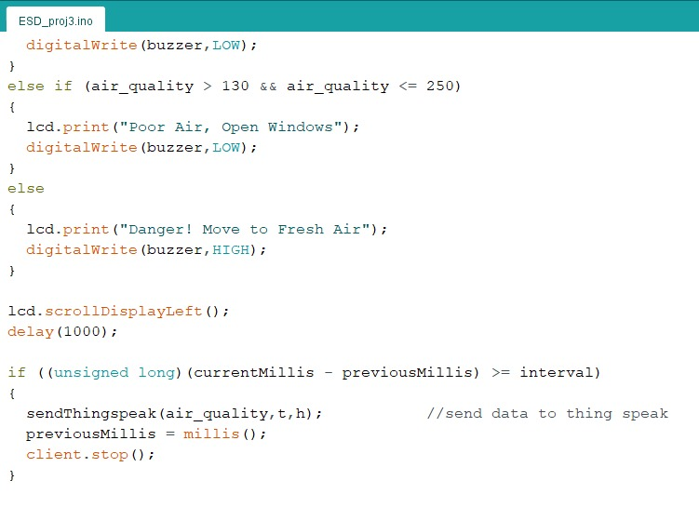

**Figure 10 Arduino IDE code window**

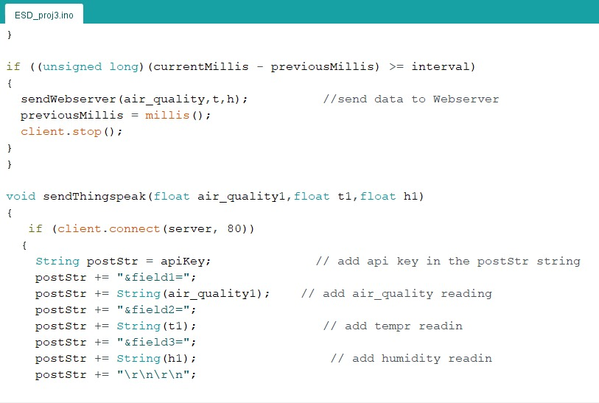

**Figure 11 Arduino IDE code window**

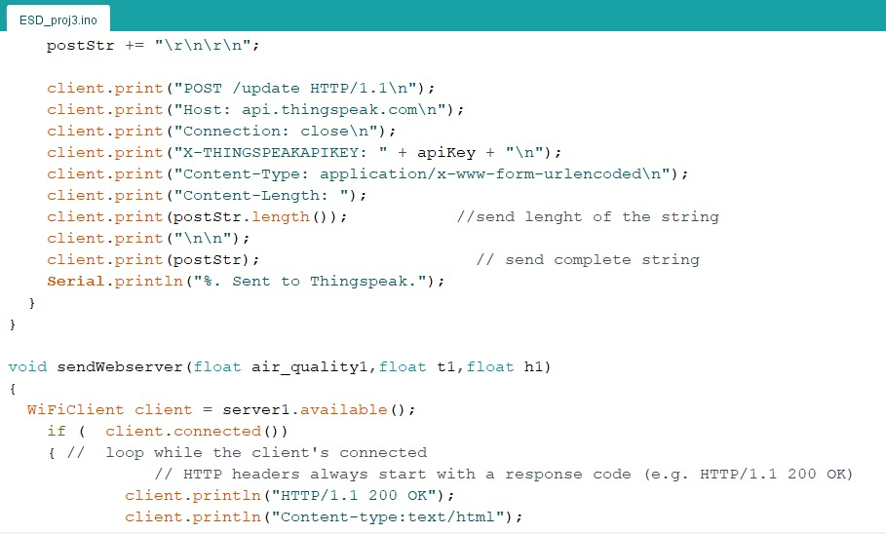

**Figure 12 Arduino IDE code window**

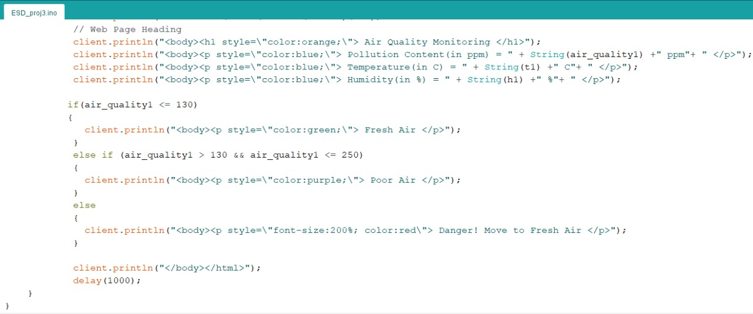

**Figure 13 Arduino IDE code window**

**COMPILER WINDOW (Refer Figure 14,15,16,17,18,19,20)**

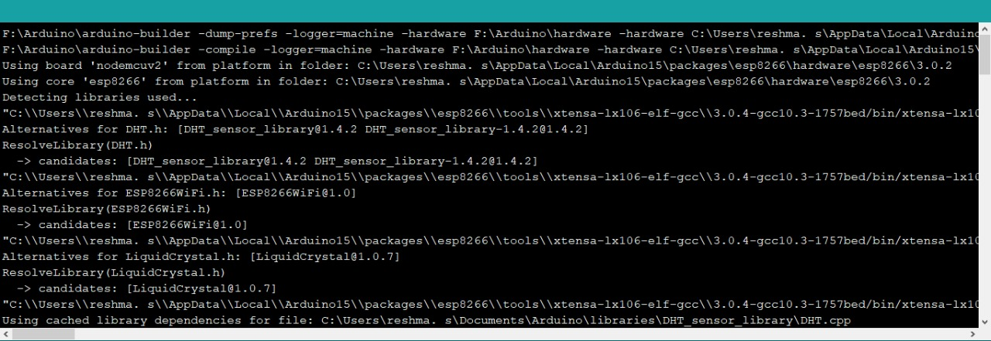

**Figure 14 Command window in Arduino IDE**

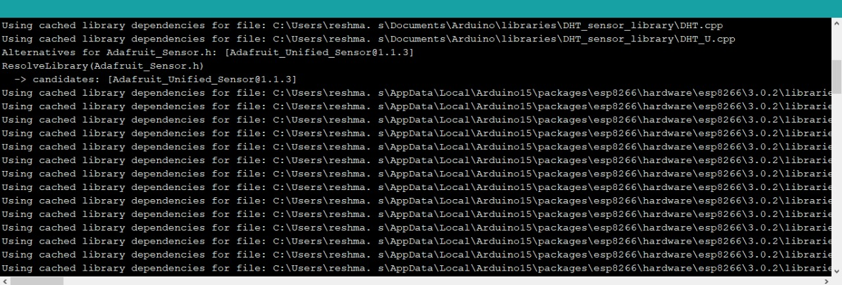

**Figure 15 Command window in Arduino IDE**

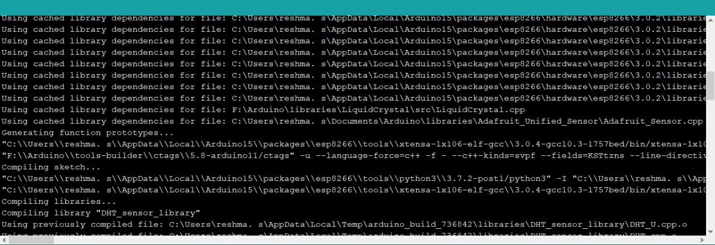

**Figure 16 Command window in Arduino IDE**

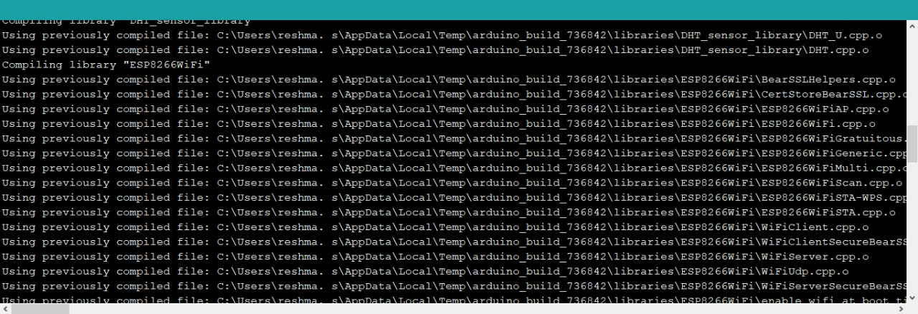

**Figure 17 Command window in Arduino IDE**

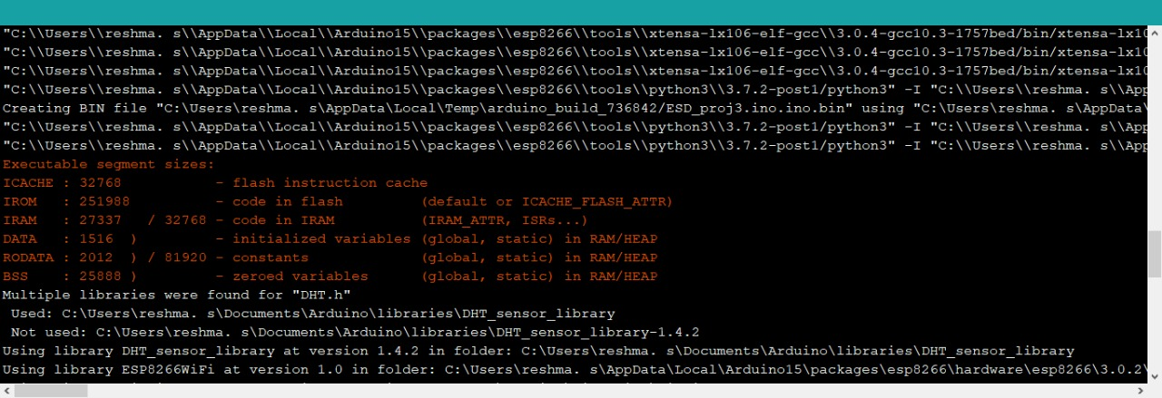

**Figure 18 Command window in Arduino IDE**



**Figure 19 Command window in Arduino IDE**

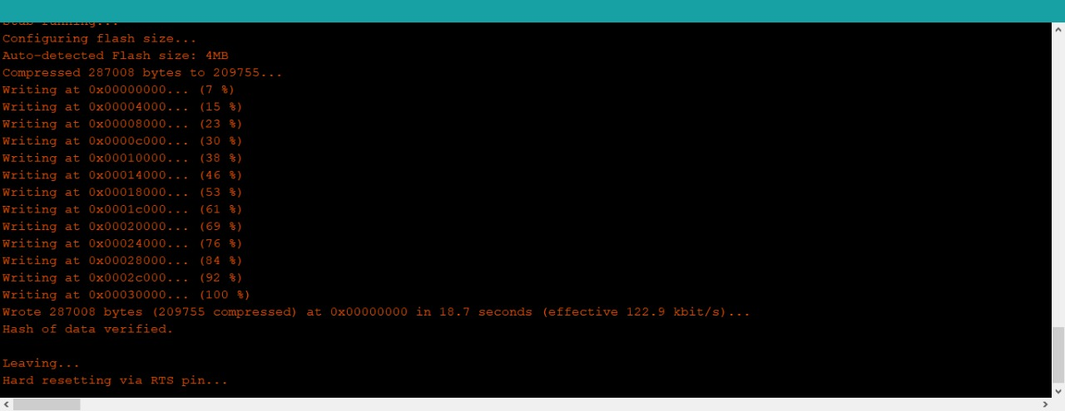

**Figure 20 Command window in Arduino IDE**

**3.3. SOFTWARE IMPLEMENTATION IN FRITZING**

**CIRCUIT DIAGRAM (Refer Figure 21)**

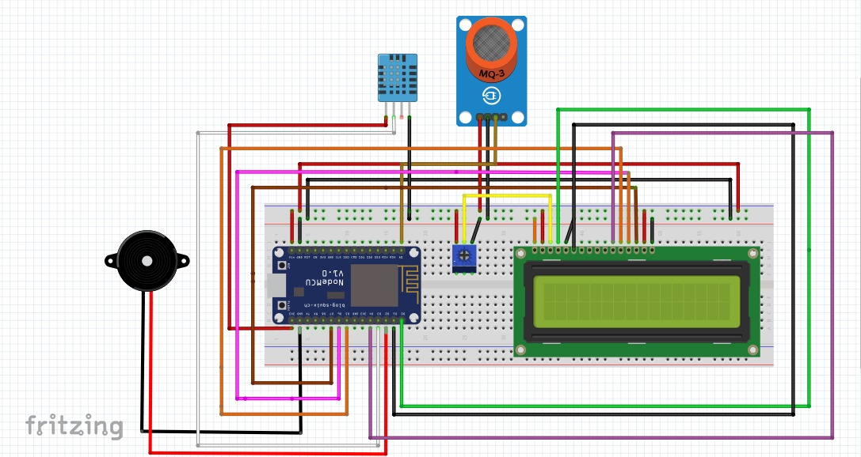

**Figure 21 Circuit Diagram**

**SCHEMATIC OF THE CIRCUIT (Refer Figure 22)**

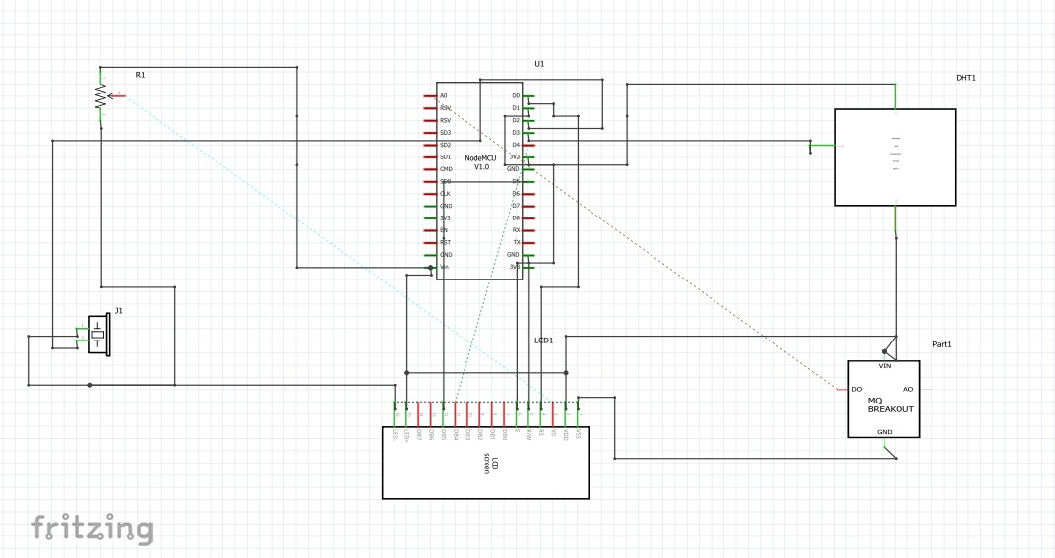

**Figure 22 Schematic circuit**

**PCB DESIGN OF THE CIRCUIT (Refer Figure 23)**

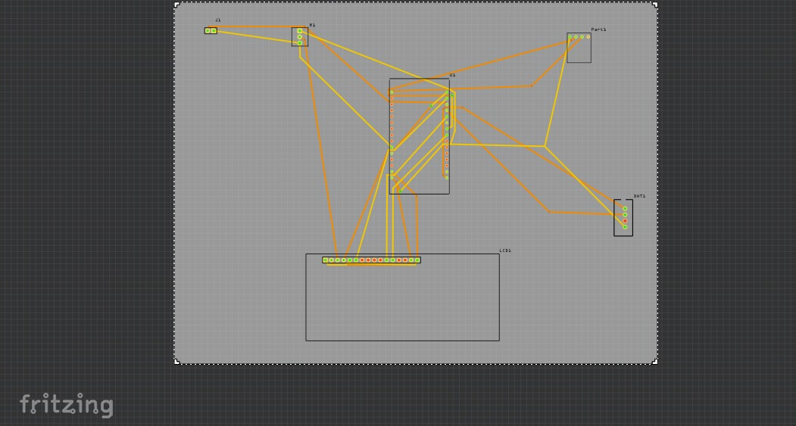

**Figure 23 PCB Design in fritzing**

**3.4. SOFTWARE IMPLEMENTATION IN THINGSPEAK**



**Figure 24 Thing speak platform**

**THINGSPEAK RESULTS (Refer Figure 25)**

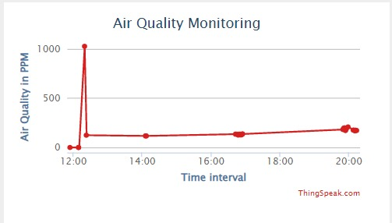

**Figure 25 Results from thing speak**

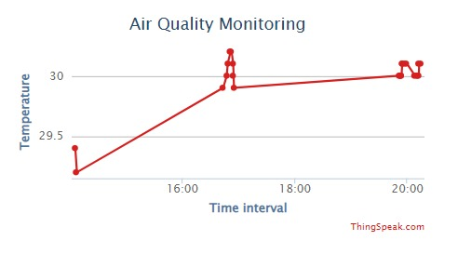

**Figure 26 Results from thing speak**

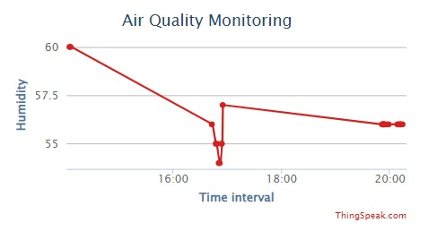

**Figure 27 Results from thing speak**

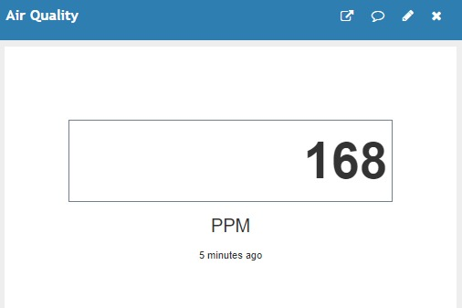

**Figure 28 Results from thing speak**

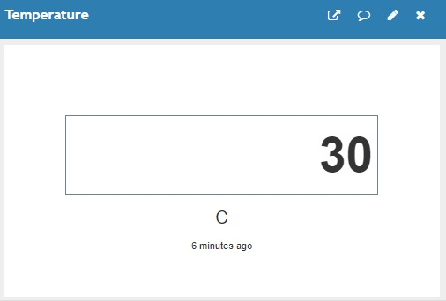

**Figure 29 Results from thing speak**

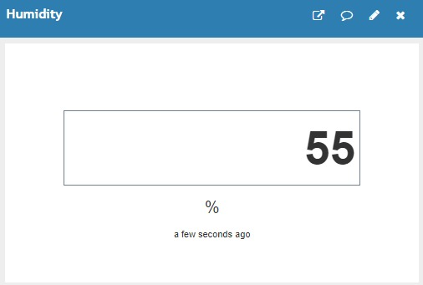

**Figure 30 Results from thing speak**

**3.5. SOFTWARE IMPLEMENTATION IN WEB PAGE**

**SERIAL MONITOR**

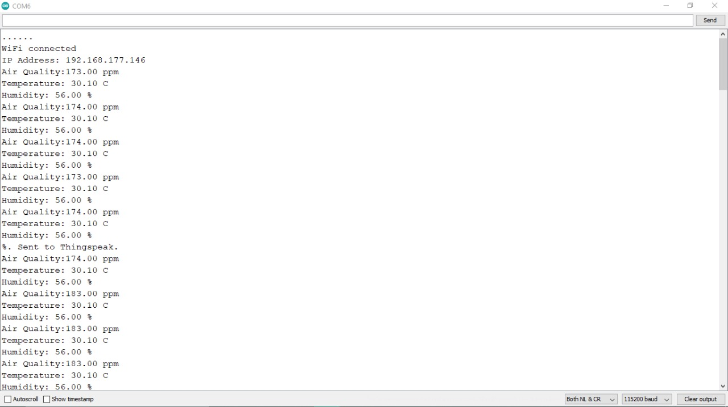

**Figure 31 Serial Monitor**

**WEBPAGE RESULTS:**

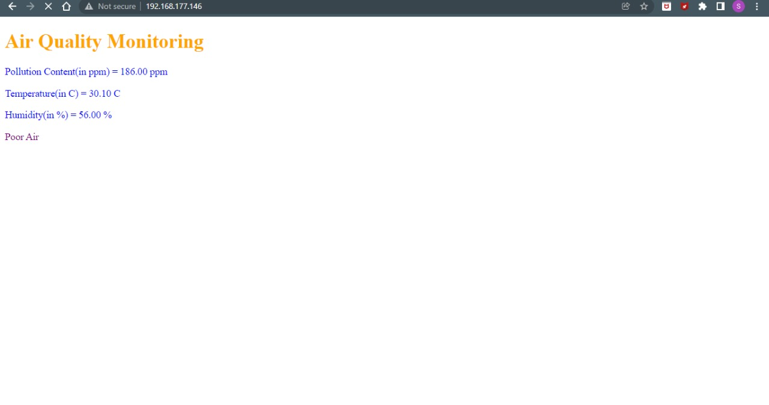

**Figure 32 Web Page Result**

**3.6. SOFTWARE IMPLEMENTATION IN IFTTT**

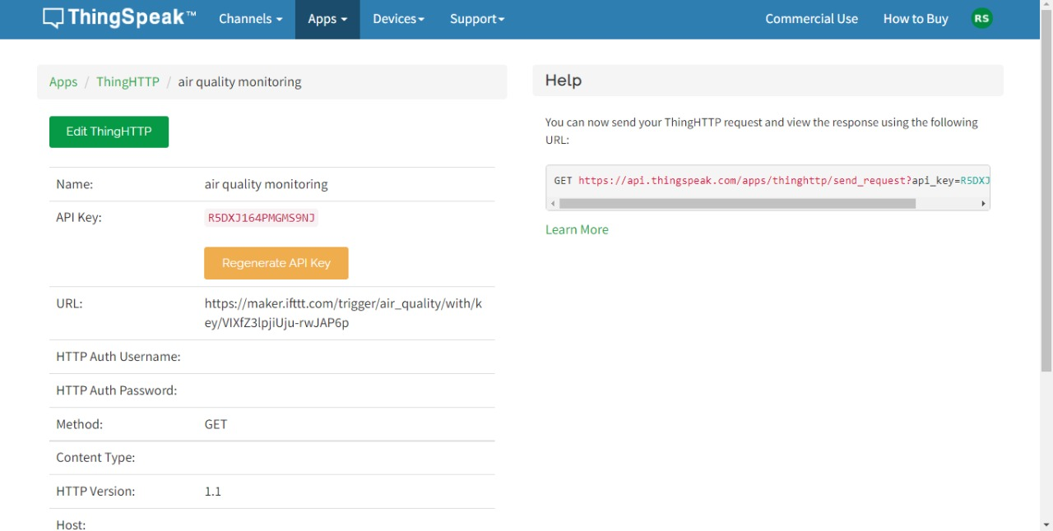

**Figure 33 ThingsHTTP in the thing speak**

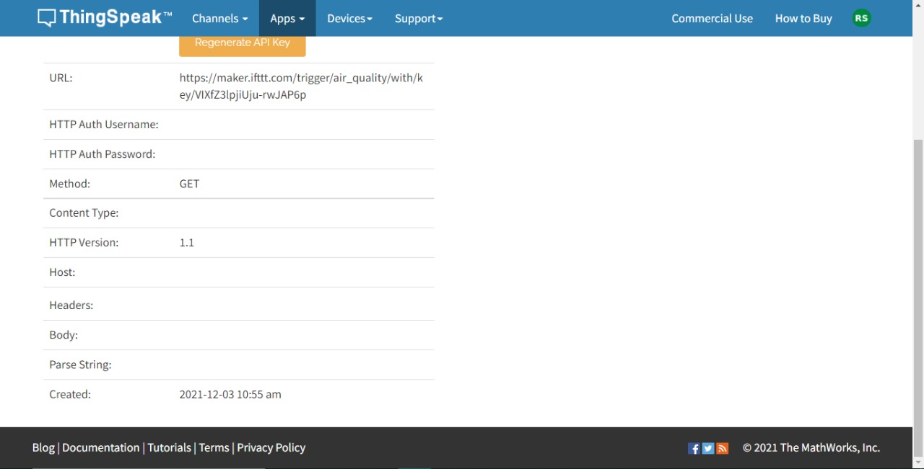

**Figure 34 ThingsHTTP in the thing speak**

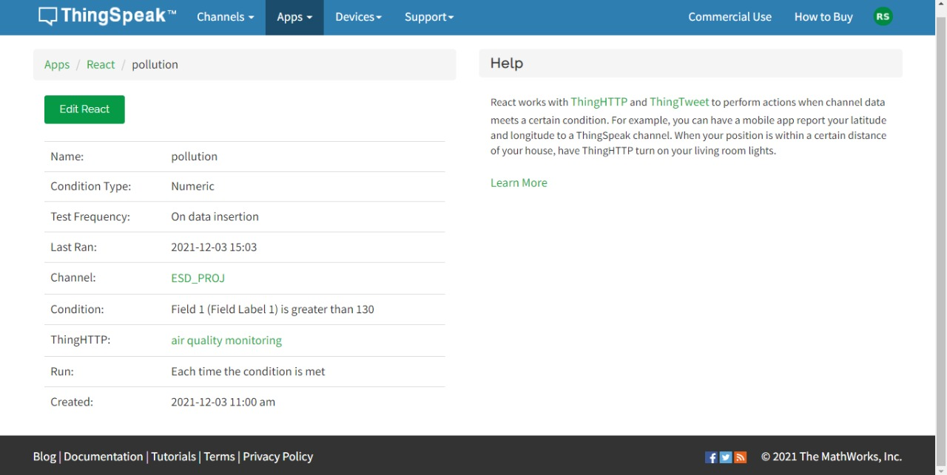

**Figure 35 React in the thing speak**

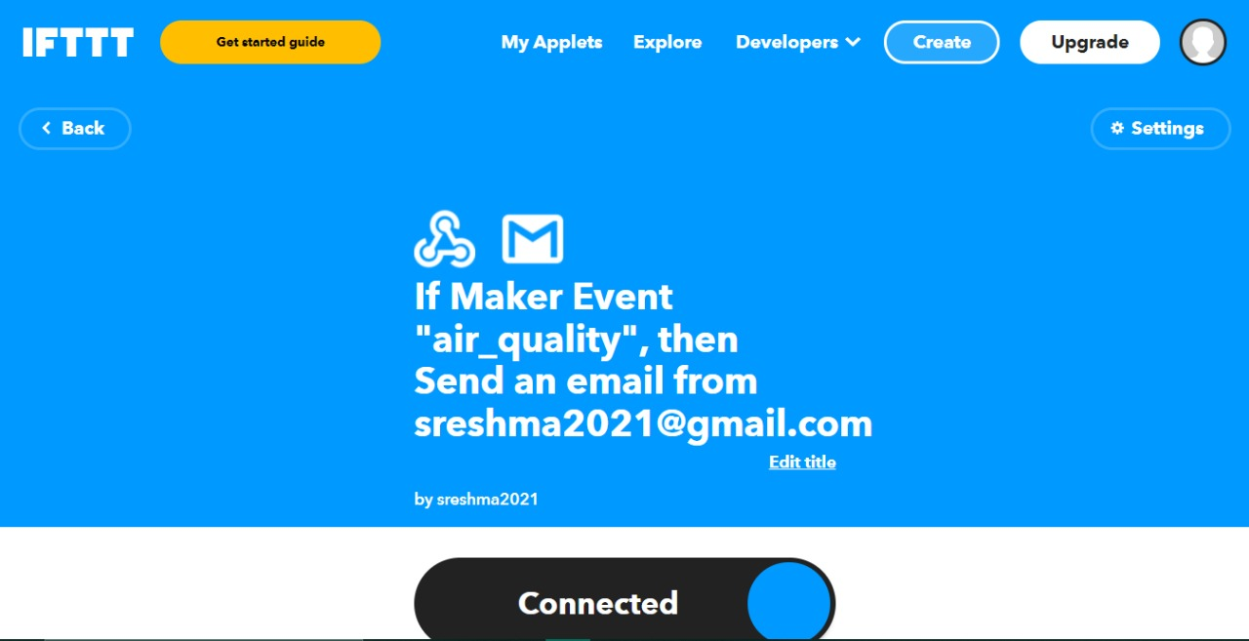

**Figure 36 IFTTT**

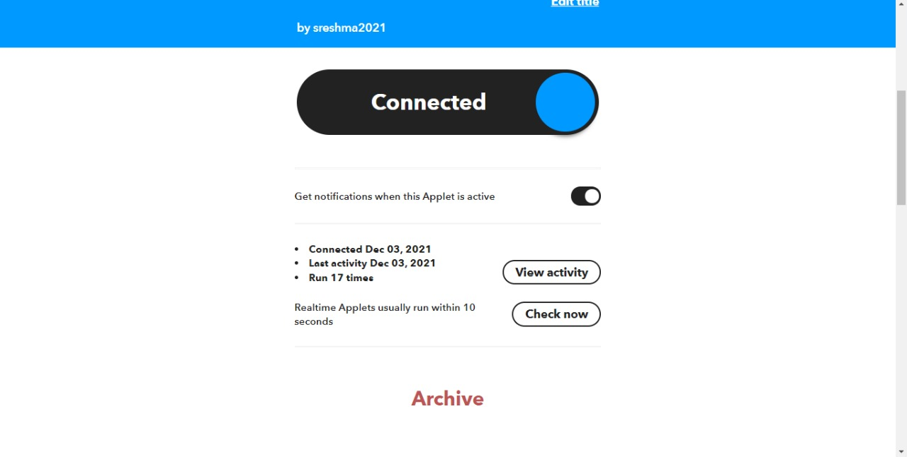

**Figure 37 IFTTT**

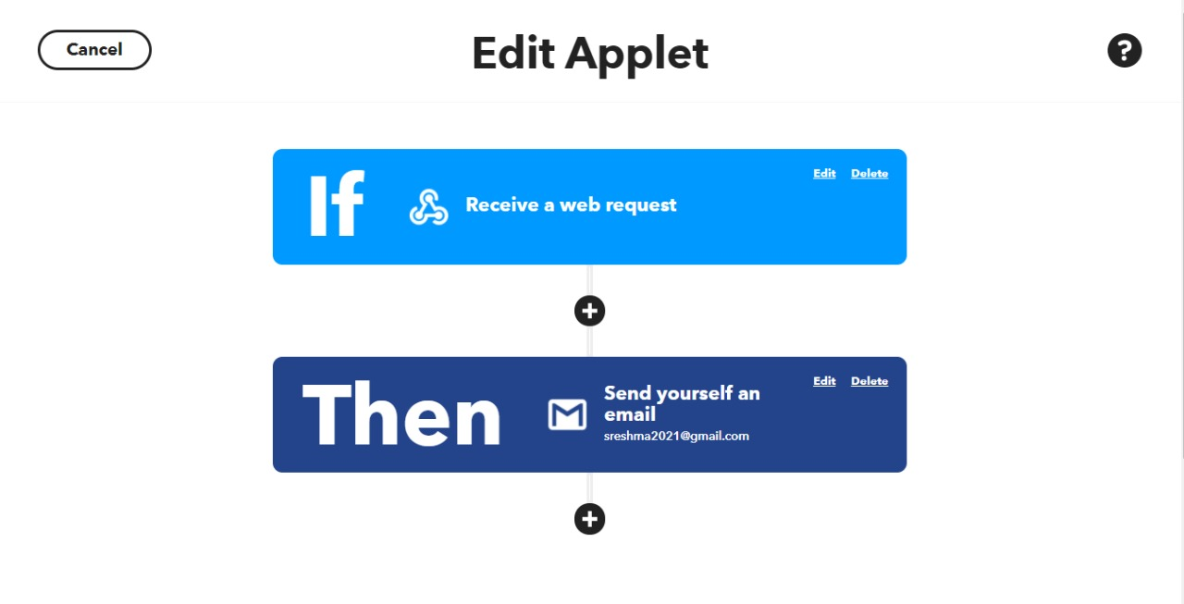

**Figure 38 IFTTT**

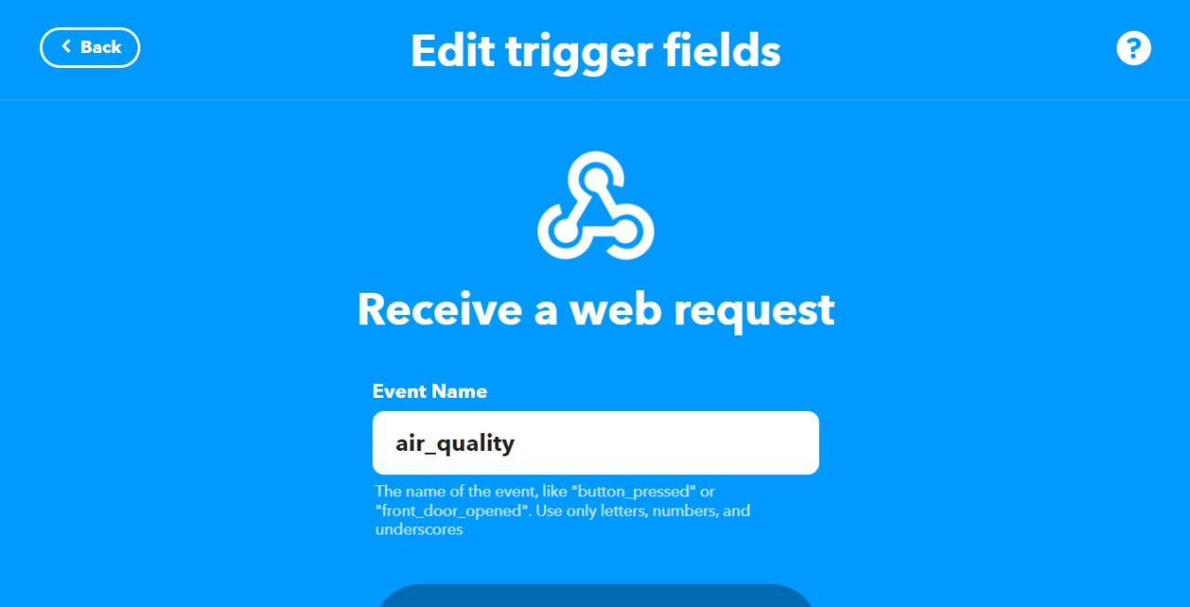

**Figure 39 This in IFTTT**

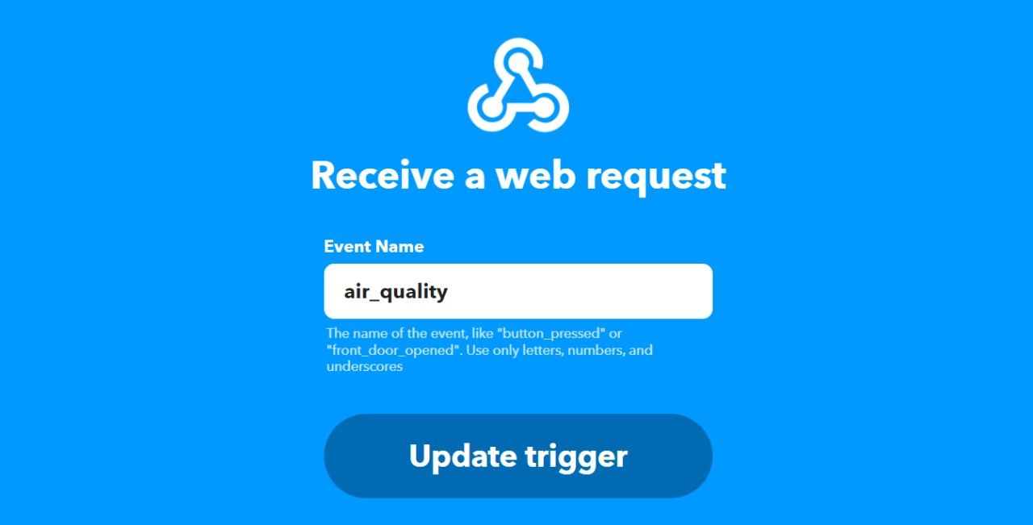

**Figure 40 This in IFTTT**

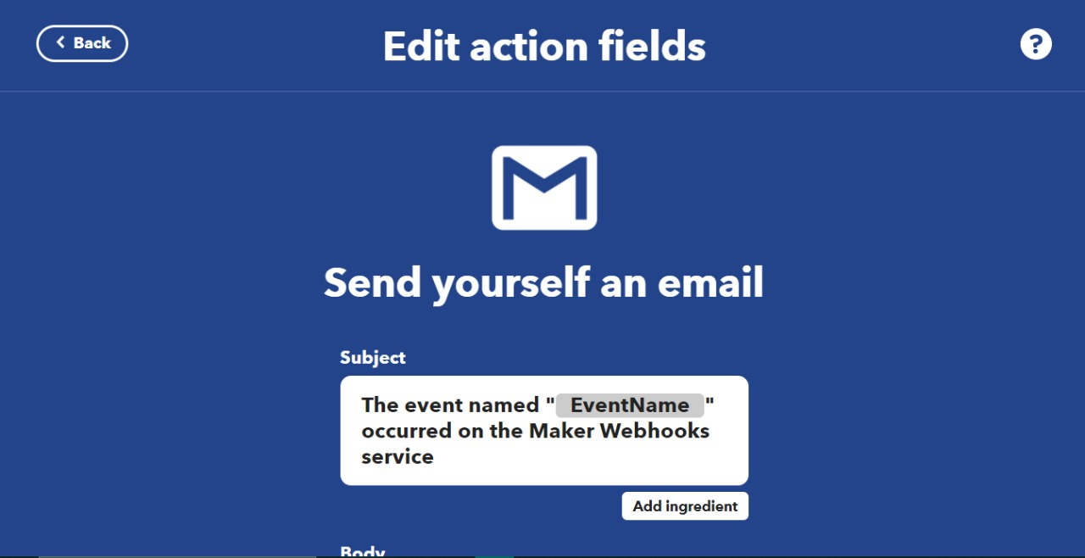

**Figure 41 That in IFTTT**

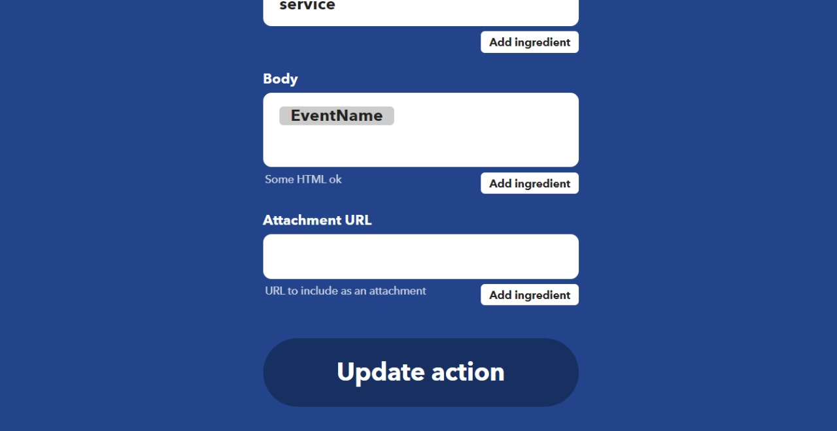

**Figure 42 That in IFTTT**

**NOTIFICATION RESULTS TO GMAIL:**

**TO 2 RECIPIENTS:**

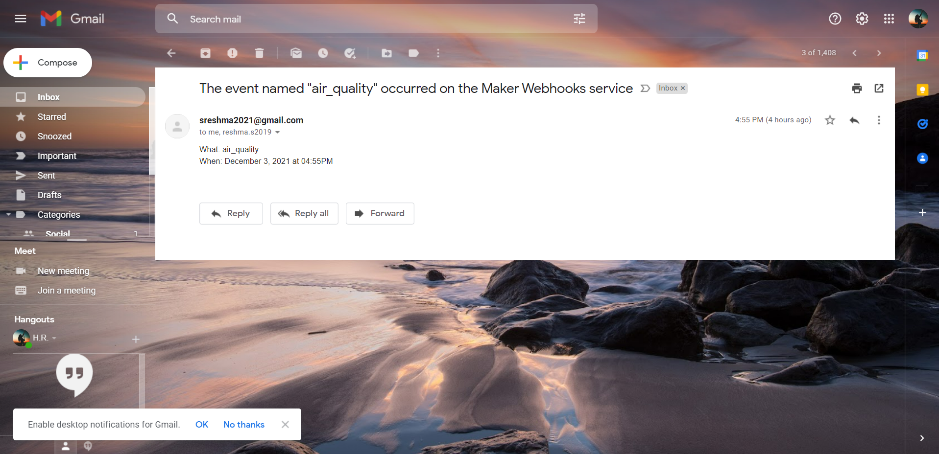

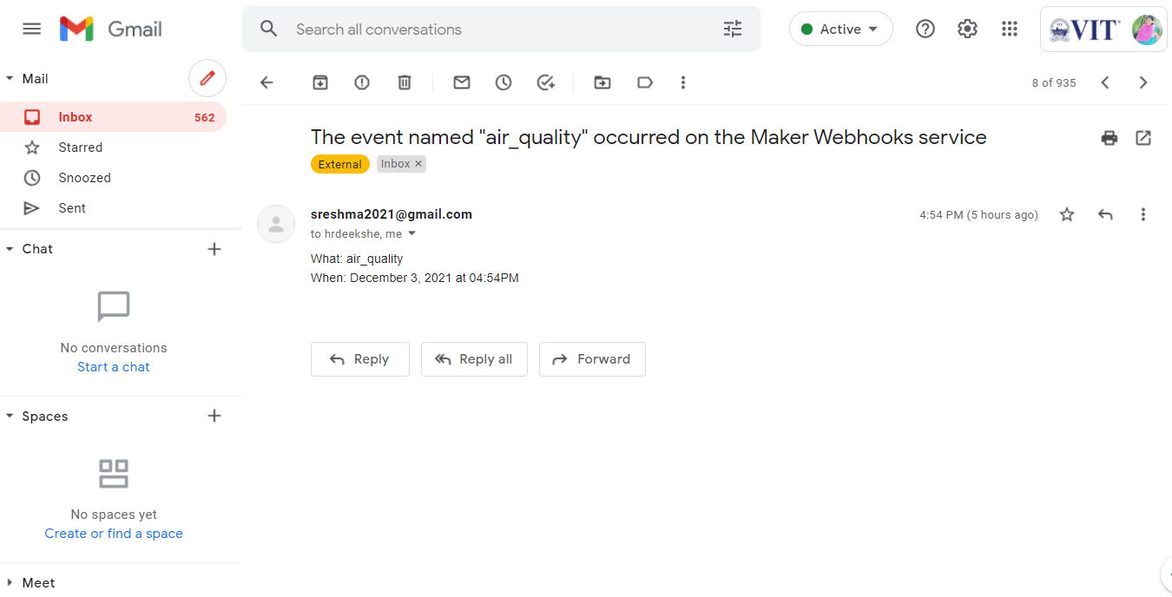

**Figure 43 Notifications to Gmail**

**NOTIFICATION RESULTS TO SMS:**

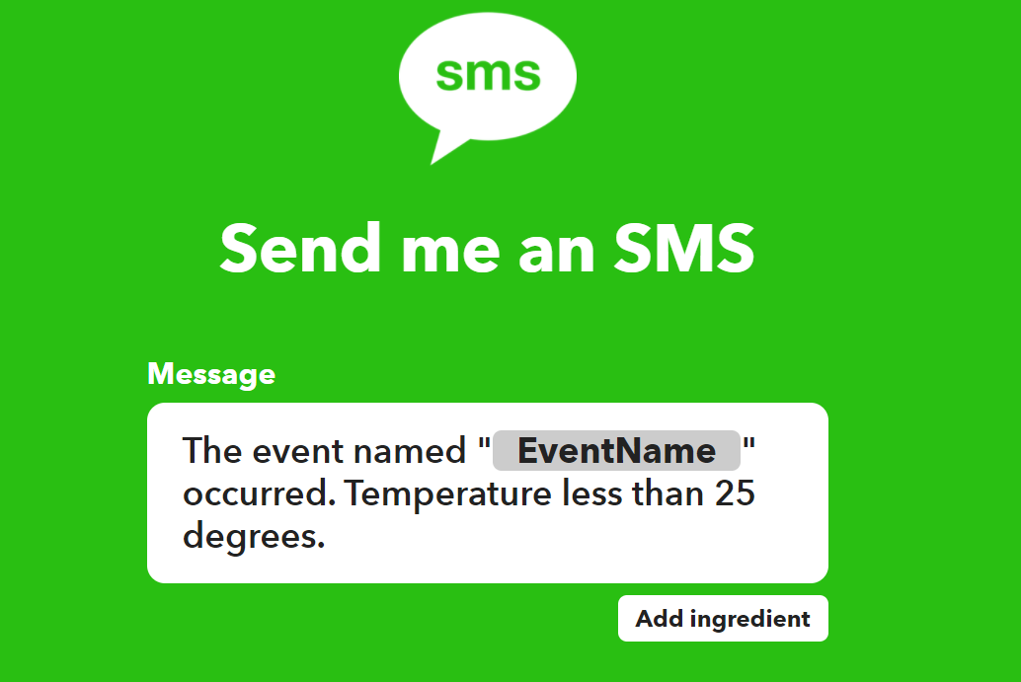

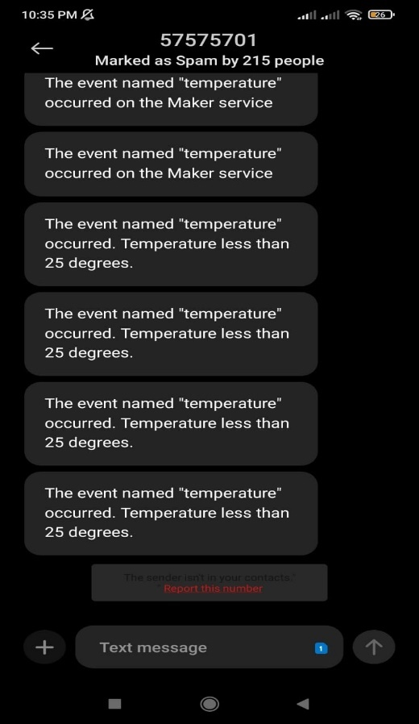

**Figure 44 Notifications to SMS**

**4. HARDWARE IMPLEMENTATION**

**4.1 HARDWARE ANALYSIS**

The breadboard consists of the Resistors, Potentiometer, Node MCU board. Laptop serves as the power supply that powers the Node MCU with 5V. They will make the thing speak, serial monitor to display the appropriate indication of air quality from the C code that is fed through Arduino IDE and also the air quality.

**4.1.1 NODE MCU ESP8266**

**NODE MCU ESP8266**

NodeMCU is an open-source Lua based firmware and **development board** specially targeted for IoT based Applications. It includes firmware that runs on the ESP8266 Wi-Fi SoC from Espressif Systems, and hardware which is based on the ESP-12 module. (Refer Figure 29)

**PIN DESCRIPTION**

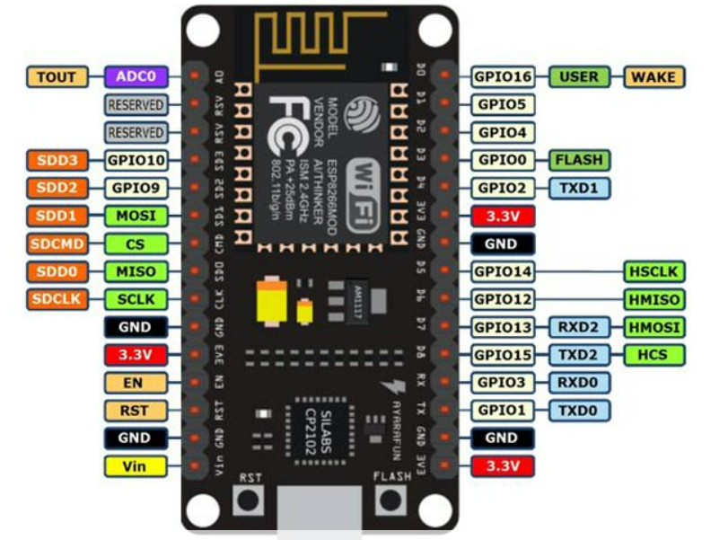

**Figure 45 shows the Pin diagram of Node MCU**

### **NODEMCU DEVELOPMENT BOARD PINOUT CONFIGURATION5**

|  |  |  |
| --- | --- | --- |
| Pin Category | Name | Description |
| Power | Micro-USB, 3.3V, GND, Vin | **Micro-USB:** NodeMCU can be powered through the USB port  **3.3V:** Regulated 3.3V can be supplied to this pin to power the board  **GND:** Ground pins  **Vin:**External Power Supply |
| Control Pins | **EN, RST** | The pin and the button reset the microcontroller |
| Analog Pin | A0 | Used to measure analog voltage in the range of 0-3.3V |
| GPIO Pins | GPIO1 to GPIO16 | NodeMCU has 16 general purpose input-output pins on its board |
| SPI Pins | SD1, CMD, SD0, CLK | NodeMCU has four pins available for SPI communication. |
| UART Pins | TXD0, RXD0, TXD2, RXD2 | NodeMCU has two UART interfaces, UART0 (RXD0 & TXD0) and UART1 (RXD1 & TXD1). UART1 is used to upload the firmware/program. |
| I2C Pins |  | NodeMCU has I2C functionality support but due to the internal functionality of these pins, you have to find which pin is I2C. |

**Table 2 shows the Pins description of Node MCU**

**Node MCU ESP8266 Specifications and features5**

* Microcontroller: Tensilica 32-bit RISC CPU Xtensa LX106
* Operating Voltage: 3.3V
* Input Voltage: 7-12V
* Digital I/O Pins (DIO): 16
* Analog Input Pins (ADC): 1
* UARTs: 1
* SPIs: 1
* I2Cs: 1
* Flash Memory: 4 MB
* SRAM: 64 KB
* Clock Speed: 80 MHz
* USB-TTL based on CP2102 is included onboard, Enabling Plug n Play
* PCB Antenna
* Small Sized module to fit smartly inside your IoT projects

**4.1.2 LCD**

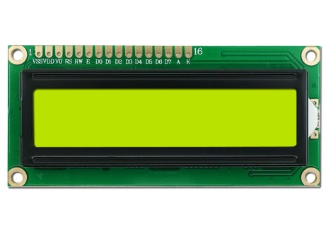

**Figure 46 LCD**

LCD modules (Figure 46) are very commonly used in most embedded projects, the reason being its cheap price, availability and programmer friendly. The appearance and the pinouts have already been visualized above now let us get a bit technical.16×2 LCD is named so because; it has 16 Columns and 2 Rows. 3

**3LCD CONFIGURATION**

|  |  |  |  |
| --- | --- | --- | --- |
| Category | Pin No. | Pin Name | Function |
| Power Pins | 1 | VSS | Ground Pin, connected to Ground |
| 2 | Vcc | Voltage Pin +5V |
| Contrast Pin | 3 | V0 / VEE | Contrast Setting, connected to Vcc thorough a variable resistor. |
| Control Pins | 4 | RS | Register Select Pin, RS=0 Command mode, RS=1 Data mode |
| 5 | RW | Read/ Write pin, RW=0 Write mode, RW=1 Read mode |
| 6 | E | Enable, a high to low pulse need to enable the LCD |
| Data Pins | 7-14 | D0-D7 | Data Pins, Stores the Data to be displayed on LCD or the command instructions |
| Backlight Pins | 15 | LED+ or A | To power the Backlight +5V |
| 16 | LED- or K | Backlight Ground |

**Table 3 shows the Pins description of LCD**

**4.1.3BUZZER**

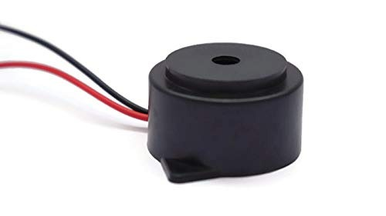

**Figure 47 BUZZER**

A buzzer (Figure 47) is a small yet efficient component to add sound features to our project/system. It is very small and compact 2-pin structure hence can be easily used on breadboard, Perf Board and even on PCBs which makes this a widely used component in most electronic applications. 4

**4.1.4. DHT11 SENSOR**

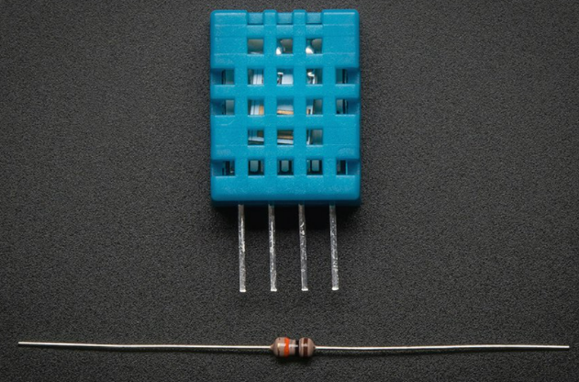The DHT11 is a basic, ultra-low-cost digital temperature and humidity sensor. It uses a capacitive humidity sensor and a thermistor to measure the surrounding air, and spits out a digital signal on the data pin (no analog input pins needed). We can get new data from it once every 2 seconds, so when using the library from Adafruit, sensor readings can be up to 2 seconds old.

This sensor comes along with a 4.7K or 10K resistor, this will be used as the pullup resistor from the data pin to VCC (Refer Figure 48)7.

**Figure 48 shows the DHT11**

|  |  |  |
| --- | --- | --- |
| No. | Parameter | Value |
| 1 | **Measures** | **Humidity & Temperature** |
| 2 | **Sensors Included** | **Capacitive Humidity Sensor & Thermistor** |
| 3 | **Humidity Range** | **20% to 80% with ±5% accuracy** |
| 4 | **Temperature Range** | **0°C to 50°C with ±2°C accuracy** |
| 5 | **Package** | **4 Pins in a single row** |
| 6 | **Operating Voltage** | **3.0V to 5.5V** |
| 7 | **Operating Current** | **0.3mA(measuring), 60uA(idle)** |
| 8 | **Resolution** | **1°C, 1%RH (8-Bit)** |
| 9 | **Response Time** | **6s-15s** |
| 10 | **Repeatability** | **±1°C, ±1%RH** |
| 11 | **Sampling Frequency** | **1Hz** |
| 12 | **Dimensions** | **27mm x 59mm x 13.5mm (1.05″ x 2.32″ x 0.53″)** |

**Table 4 shows the specifications of DHT117**

DHT11 Pinout consists of 4 Pins in total, which are shown in below table7:

|  |  |  |
| --- | --- | --- |
| Pin# | Type | Parameters |
| Pin#1 | **Vcc** | **Provide 3.3V to 5V at this pin.** |
| Pin#2 | **Data** | **This pin provides a digital output.** |
| Pin#3 | **N/C** | **Not Connected.** |
| Pin#4 | **Ground** | **This pin is used for Ground (Connected to 0V or GND ).** |

**Table 5 shows pin description of DHT11**

**4.1.5 MQ135 GAS SENSOR**

The MQ135 is used in air quality control equipment. It operates from 2.5V to 5.0V and can provide both digital and analog output.

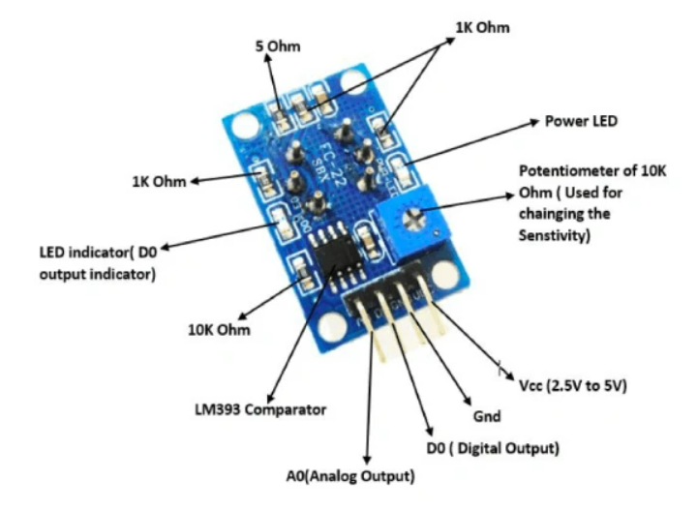

**Figure 49 shows the MQ135 Gas sensor**

**SPECIFICATIONS OF MQ135 GAS SENSOR6**

* Operating Voltage: 2.5V to 5.0V
* Power consumption: 150mA
* Detect/Measure: NH3, CO2, Alcohol, Benzene, Smoke
* Typical operating Voltage: 5V
* Digital Output: 0V to 5V (TTL Logic) @ 5V Vcc
* Analog Output: 0-5V @ 5V Vcc

|  |  |  |
| --- | --- | --- |
| Pin No | Pin Name | Description |
| 1 | Vcc | Used to power the sensor, Generally the operating voltage is +5V. |
| 2 | Ground | Used to connect the module to system ground. |
| 3 | Digital Out | You can also use this sensor to get digital output from this pin, by setting a threshold value using the potentiometer. |
| 4 | Analog Out | This pin outputs 0-5V analog voltage based on the intensity of the gas. |

**Table 6 shows pin description of MQ135 Gas sensor Module**

**POWER SUPPLY**

The power supply will be 5V batteries to supply power. The power supply will connect to all the other components through the breadboard and wires.

**4.1.6 OUTPUTS OBTAINED FROM HARWARE**

Entire Hardware Setup for the Project is shown in figure. (Refer Figure 50)

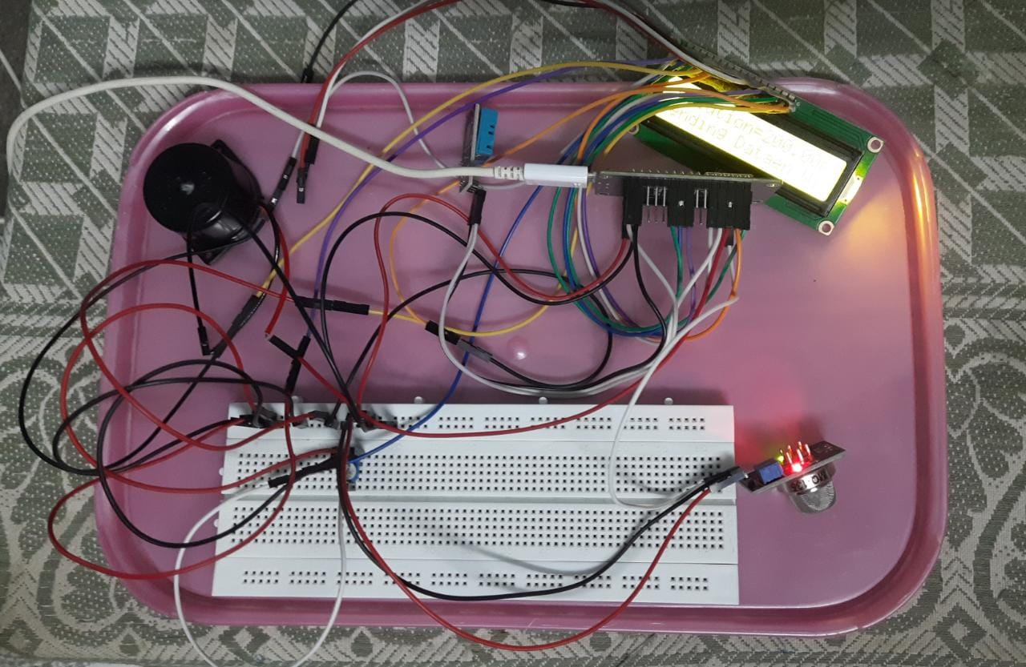

**Figure 50 Whole circuit setup of Air quality monitoring system**

**LCD OUTPUT**

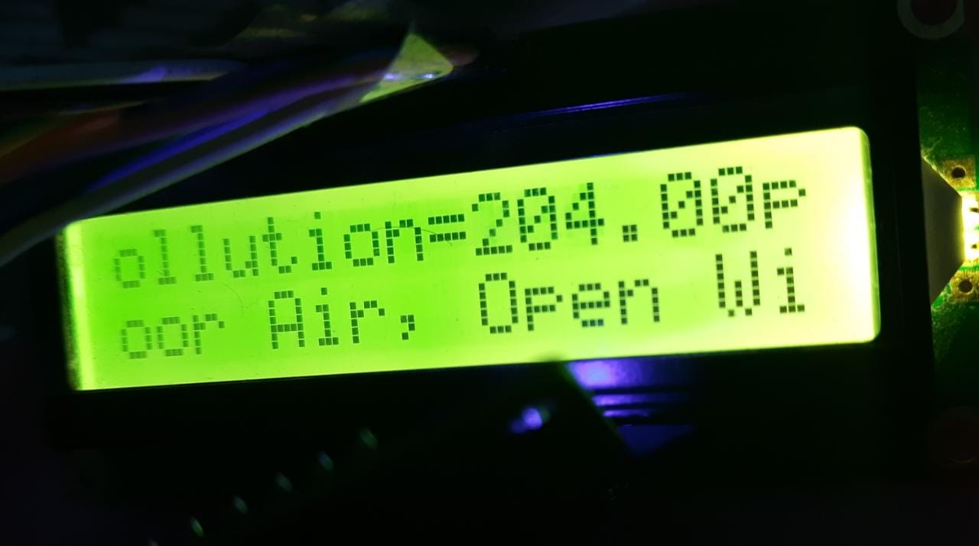

**Figure 51 LCD Output of the project**

**5.1 APPLICATIONS**

* **City**

Nowadays many people opt for residing in the cities. So, that would definitely cause air quality problems in those areas. This has to be monitored so that we can know what is the quality of air that we are inhaling.

* **Mining**

In Mining, the extraction process depletes the surroundings such as producing dirty air which is really harmful to the people who are working. This system can be very useful in these department.

* **Industry**

As we all know, Industrial pollution is the major cause for the air pollution. Here this system serves the best out of all the applications.

* **Construction**

In order to expand the human civilisation, the construction takes place. As the construction activity creates dust pollution, we can use this system to determine the air quality

* **Campus**

School students and college students are spending most of the time in school and college. It is essential to maintain fresh air in the campus. For this to happen this system can be used to monitor the quality of air.

**5.2**  **ADVANTAGES**

* Easy installation
* Minimal maintenance
* Sends a notification to let you know if the air quality is fresh or not
* Compact design
* Low power consumption and reduces wastage

**DISADVANTAGES**

* Fluctuations in Gas Sensor.
* The rust, foul and deteriorate
* No Warranty or Guarantee

**5.3 CONCLUSION**

So, we have simulated the virtual air quality monitoring system circuit in fritzing and also finished the hardware part using the Node MCU. Now we can easily see the indication of the air quality (in terms of ppm) in the LCD display of the circuit. We have implemented air quality monitoring system using IOT and gas sensors. This system is very simple and user friendly and can be used in any environmental conditions. This project is very useful in pollution prone areas and it can also be used in cites. From this project we can get the precise values rather than the average value especially in remote areas. In future, this system can be extended in real time applications to many places.

**5.4 REFERENCES**

1. European Environmental Agency (EEA) 2015 Air quality in Europe — 2015 report
2. Schneider P, Castell N, Vogt M, Dauge F R, Lahoz W A and Bartonova A 2017 Mapping urban air quality in near real-time using observations from low-cost sensors and model information Environ. Int.
3. <https://components101.com/displays/16x2-lcd-pinout-datasheet>
4. <https://components101.com/misc/buzzer-pinout-working-datasheet>
5. <https://components101.com/development-boards/nodemcu-esp8266-pinout-features-and-datasheet>
6. <https://components101.com/sensors/mq135-gas-sensor-for-air-quality>
7. <https://www.theengineeringprojects.com/2019/03/introduction-to-dht11.html>

**BIODATA**



Name: Deekshetha H R

Mobile Number: 9498553390

E-mail: [deekshetha.hr2019@vitstudent.ac.in](mailto:deekshetha.hr2019@vitstudent.ac.in)

Permanent Address: 15 AC, R.K. Nagar, Opp Ramakrishna School, Denkanikottai Road, Hosur 635109



Name: S Reshma

Mobile Number: 9360306775

E-mail: [reshma.s2019@vitstudent.ac.in](mailto:reshma.s2019@vitstudent.ac.in)

Permanent Address: F1, P No 25 Mudalavan Flats, Third Street Eb Colony, Adambakkam, Chennai, 600088, Tamil Nadu



Name: Sukkrishvar Vijay

Mobile Number: 9962555422

E-mail: [sukkrishvarvijay.s2019@vitstudent.ac.in](mailto:sukkrishvarvijay.s2019@vitstudent.ac.in)

Permanent Address: Korattur, Chennai.



Name: Shrimayee Deshpande

Mobile Number: 9323230222

E-mail: [shrimayee.deshpande2019@vitstudent.ac.in](mailto:shrimayee.deshpande2019@vitstudent.ac.in)

Permanent Address: Pimple Saudagar, Pune, Maharashtra.